Task Description#1  
• Try 3 different prompts to generate a factorial function.  
Expected Output#1  
• Comparison of AI-generated code styles

Prompt: write a programme to calculate a factorial of a given number( using functions).

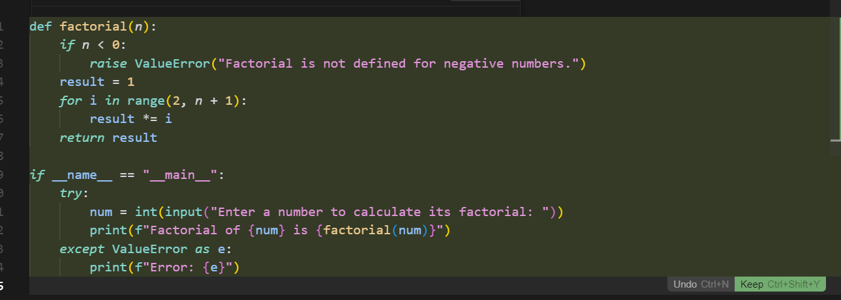

Output:

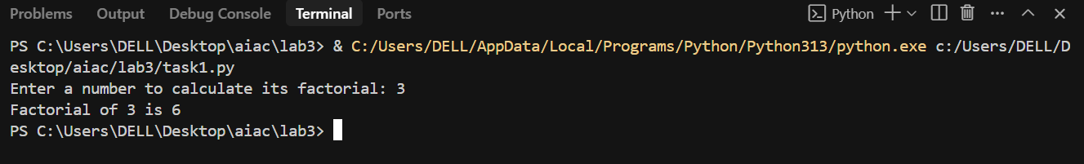

Prompt: write a programme to calculate factorial of number by taking multiple input values.

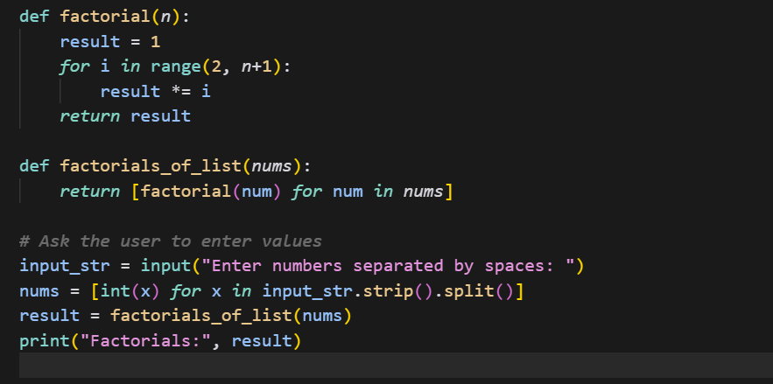





Output:

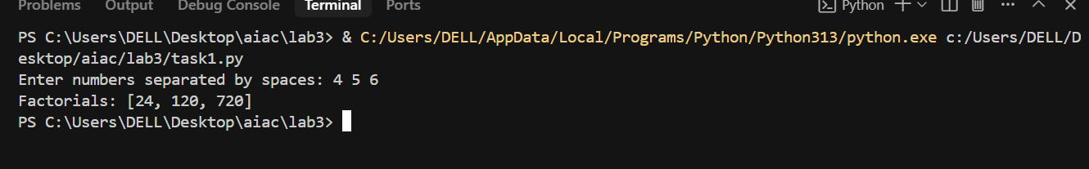

Prompt: write a programme to calculate factorial of number by taking input values.

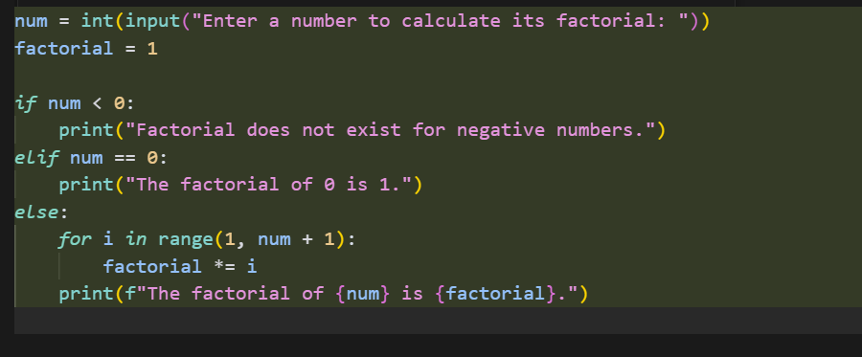

Output:

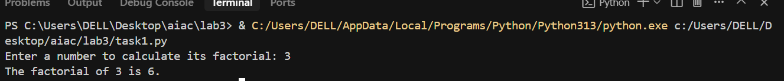

Task Description#2  
• Provide a clear example input-output prompt to generate a sorting function.  
Expected Output#2  
• Functional sorting code from AI

Prompt: Write a programme for sorting the numbers in ascending and descending order odd and even numbers in a menu by asking the input values from the user.

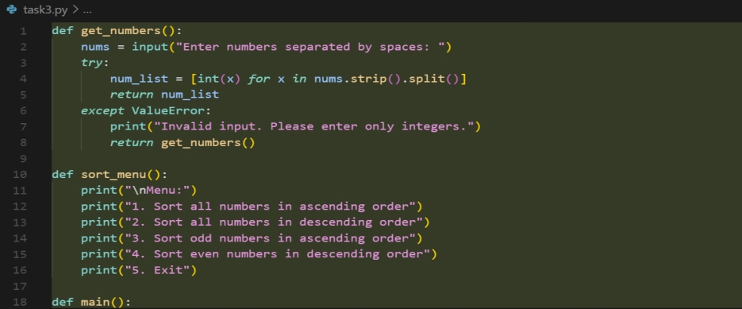

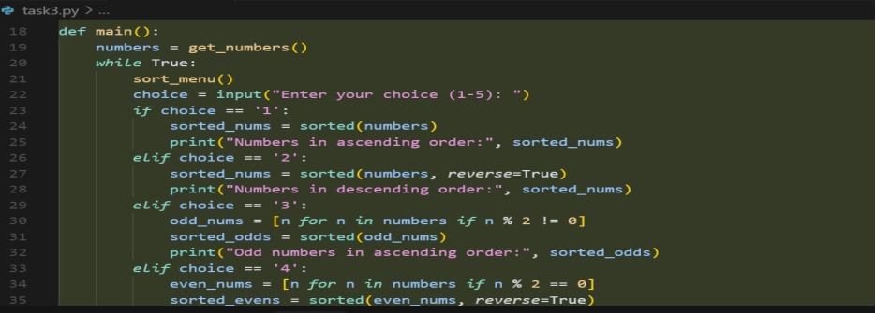

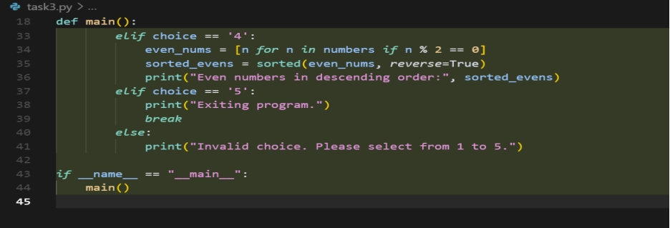

Output:

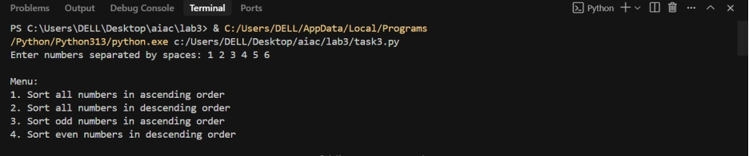

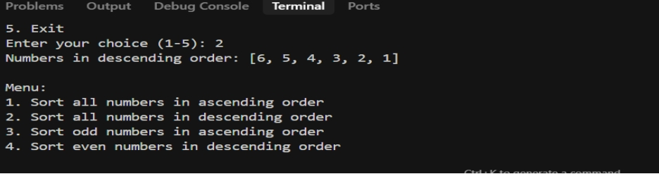

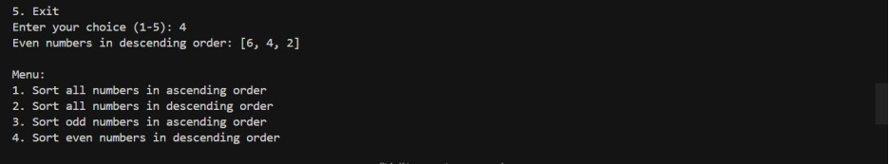

Task Description#3  
• Start with the vague prompt “Generate python code to calculate power bill” and  
improve it step-by-step  
Expected Output#3  
• Enhanced AI output with clearer prompts.

Prompt1: generate a python code to calculate power bill .

Prompt2: ask the details of the customer from the user and to show the pervious bill amount .

Prompt3: display it.

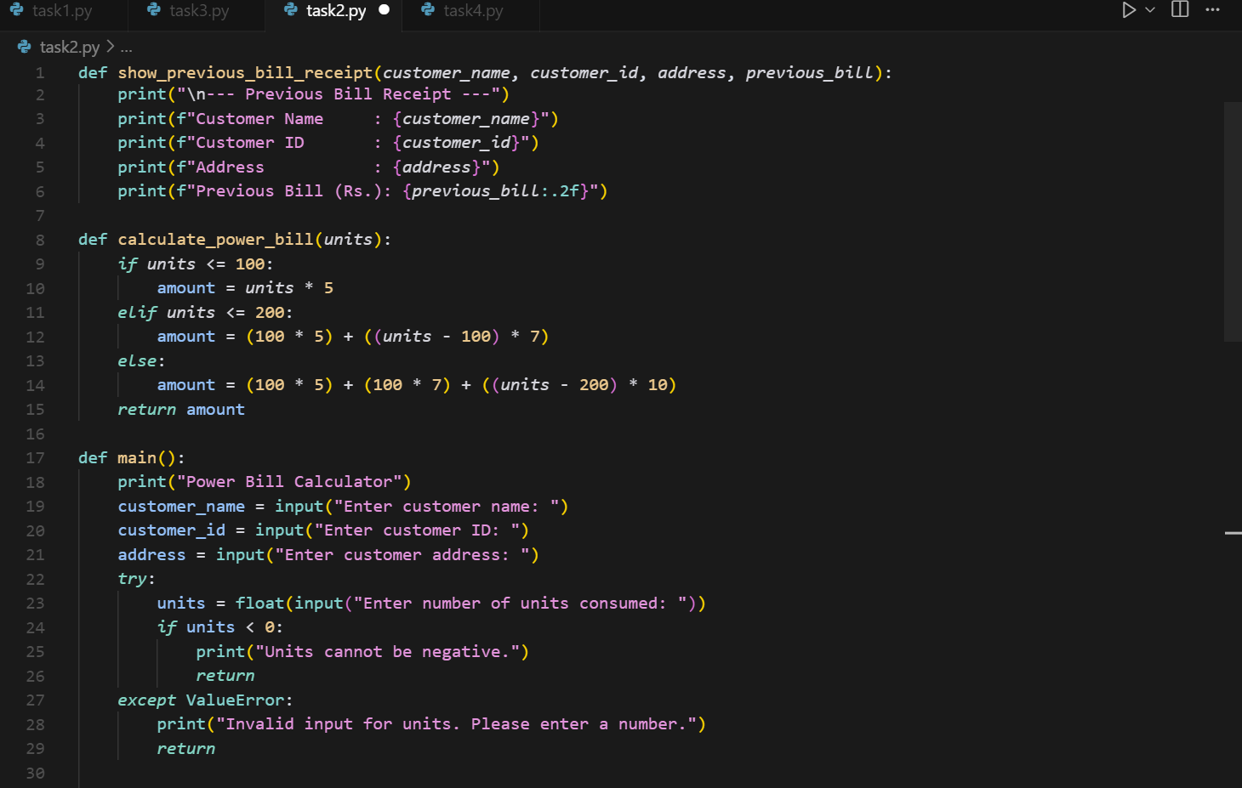

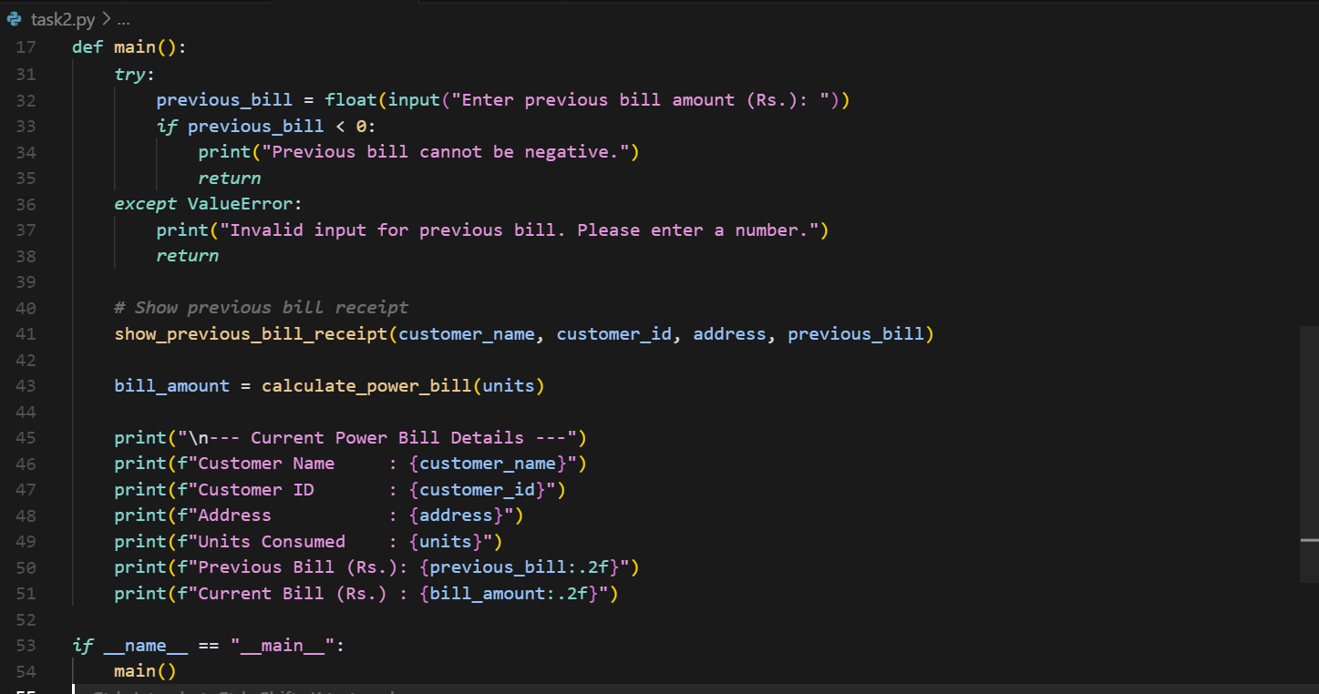

Output:

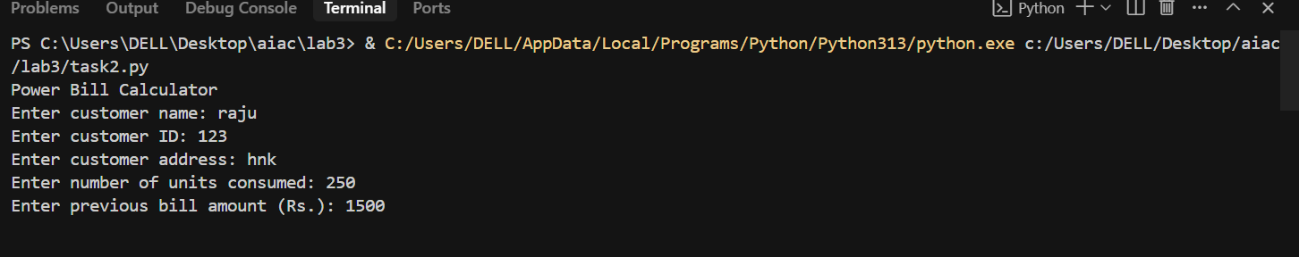

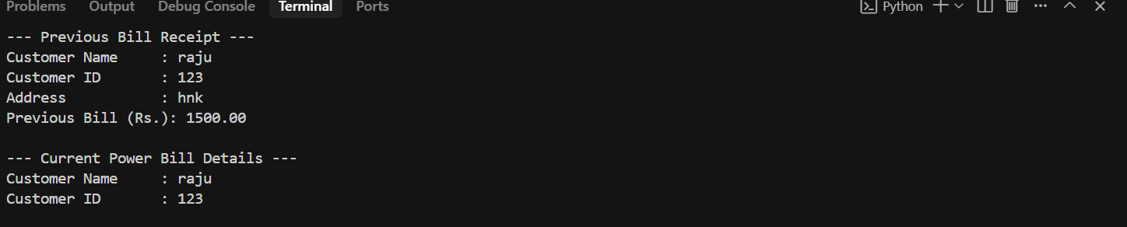

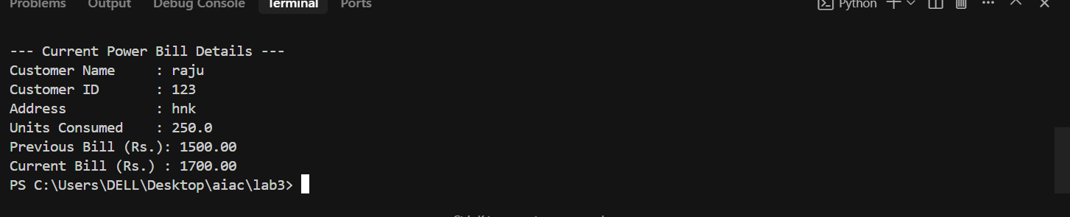

Task Description#4  
• Write structured comments to help AI generate two linked functions (e.g., login_user()  
and register_user()).  
Expected Output#4  
• Consistent functions with shared logic

Prompt: generate two linked function login_user and register_user and ask the input values from the user in a menu and display it.

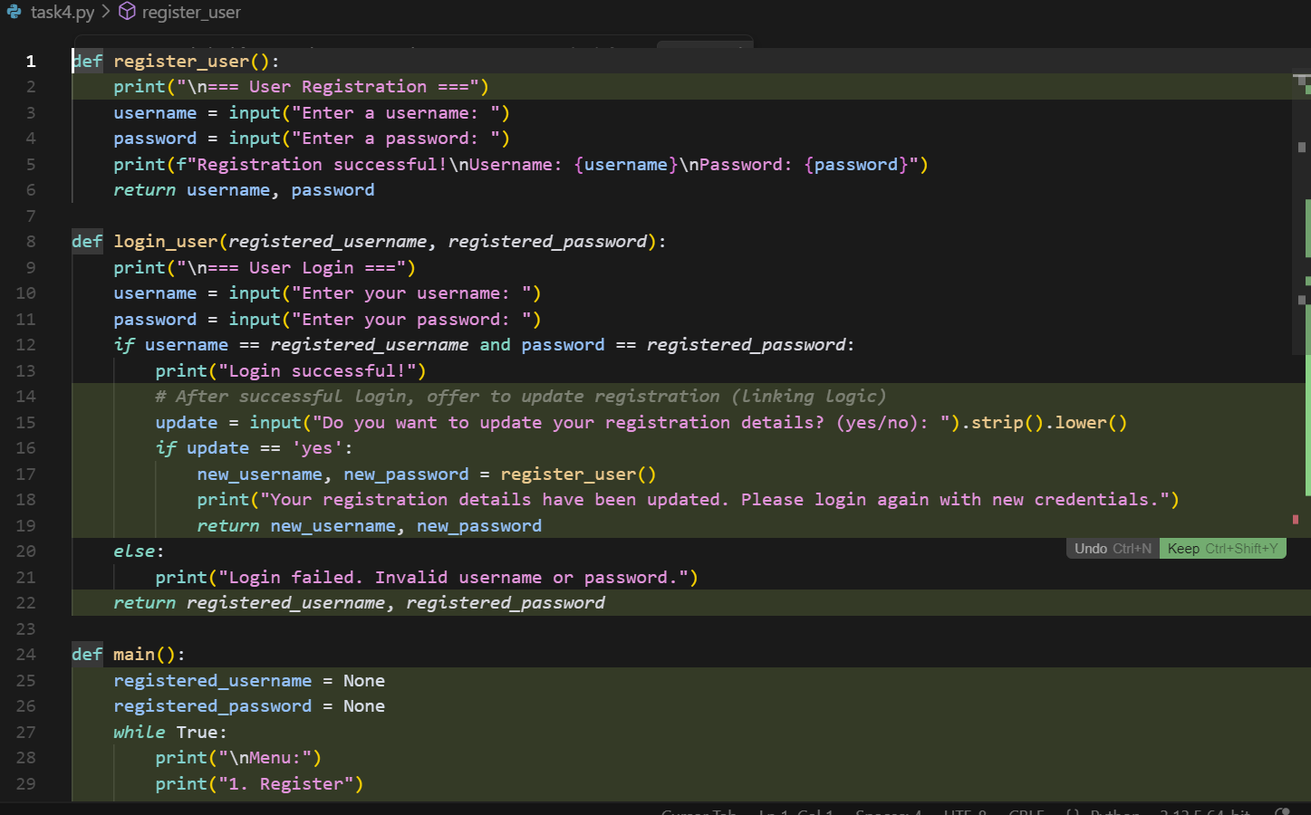

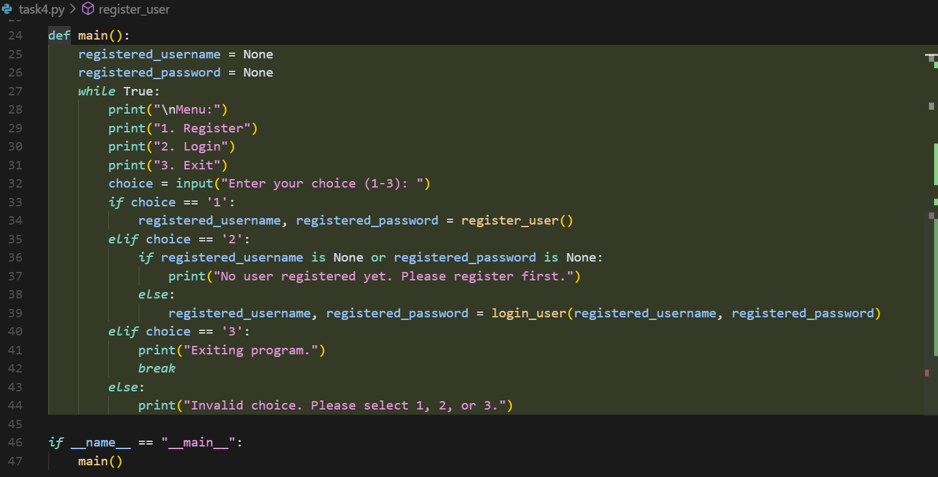

Output:

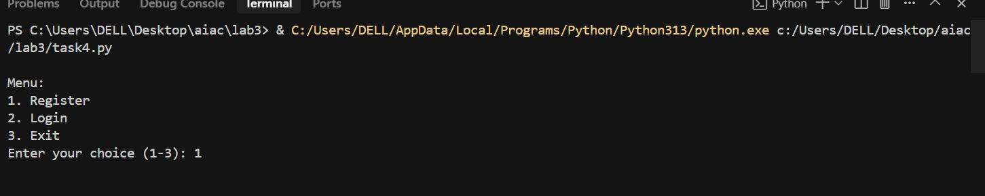

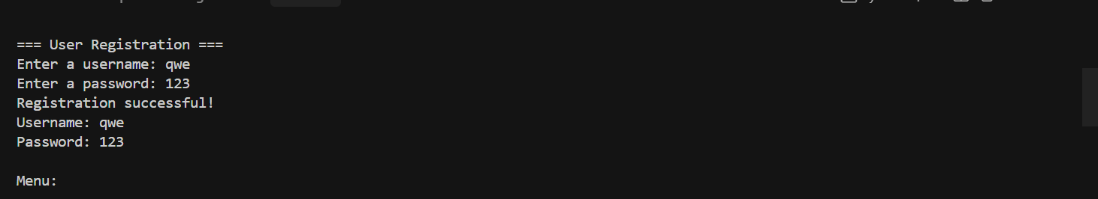

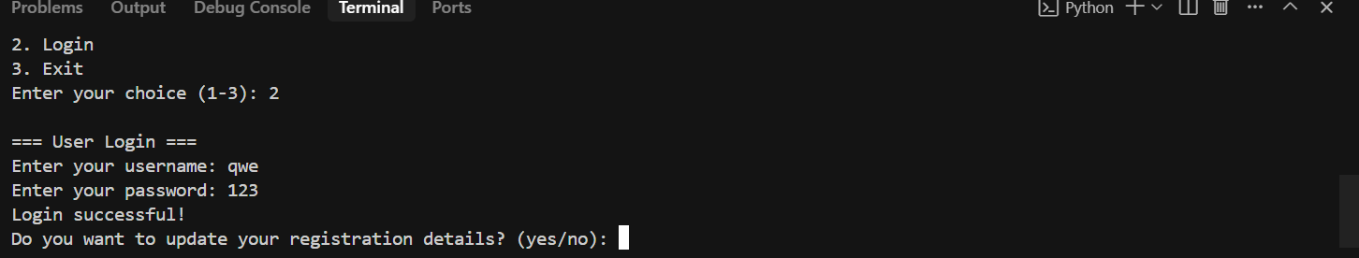

Task Description#5  
• Analyzing Prompt Specificity: Improving Temperature Conversion Function with  
Clear Instructions  
Expected Output#5  
• Code quality difference analysis for various prompts

Prompt:generate a function by improving temperature conversion function in a menu by asking input values from the user and display it

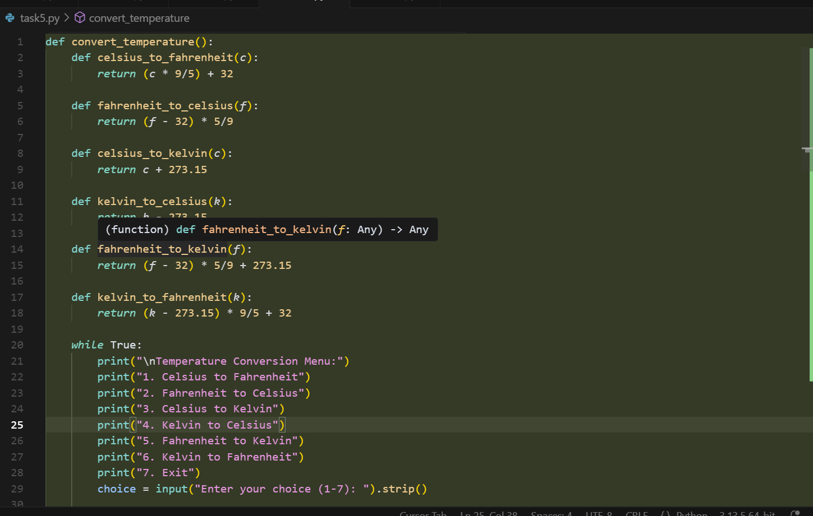

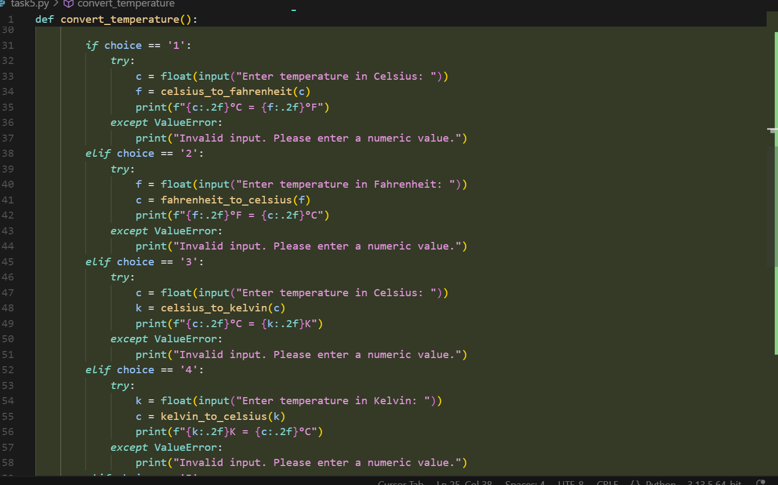

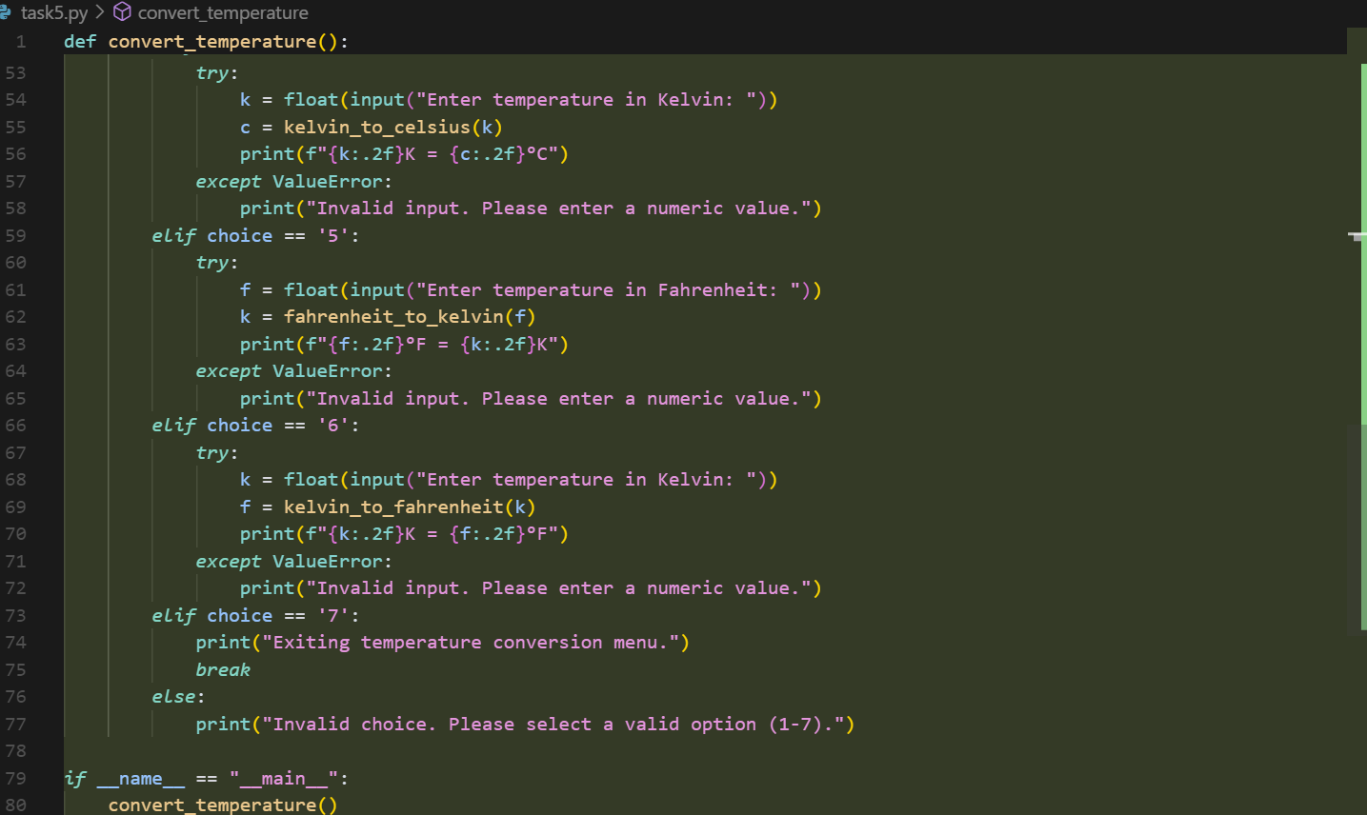

Output:

